Week -3 Homework-2

Name: Himavanth reddy putta Id:18759

Q35) **Tree Traversal:**

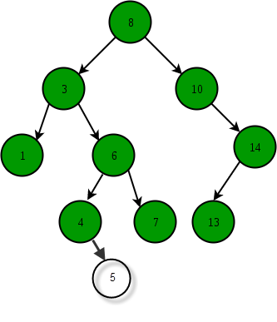

Please provide the following [Tree Traversal](https://hc.labnet.sfbu.edu/~henry/npu/classes/algorithm/tutorialpoints_dsa/slide/tree_traversal.html)

* In-order Traversal
* Pre-order Traversal
* Post-order Traversal

**In order traversal:** Left – root – right

1,3,4,5,6,7,8,10,13,14

**Pre-order:** root – left – right

8,3,1,6,4,5,7,10,14,13

**Post-order:** left – right – root

1,5,4,7,6,3,13,14,10,8

**Python code as per question:**

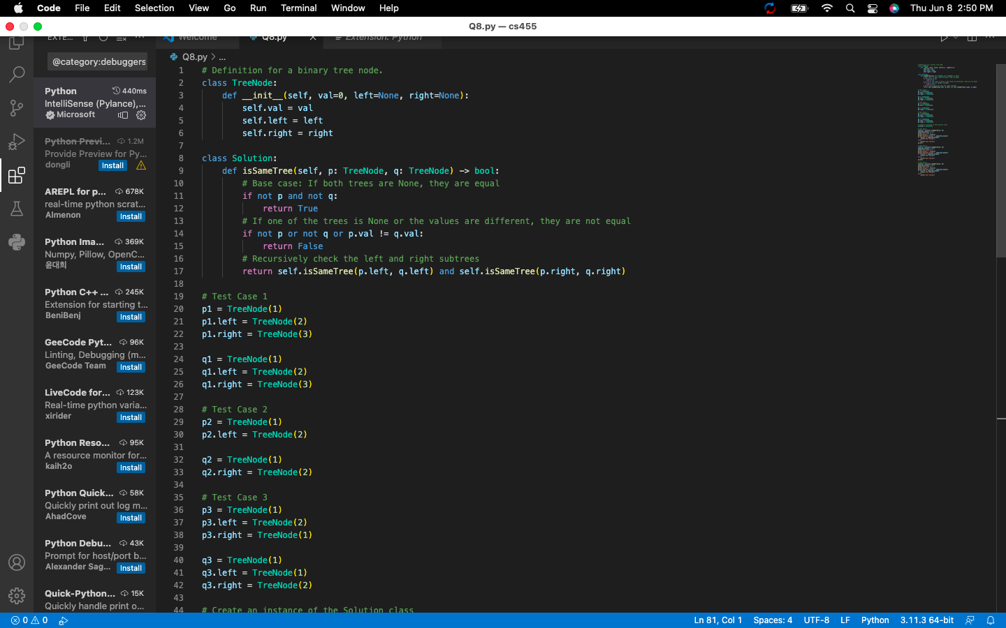

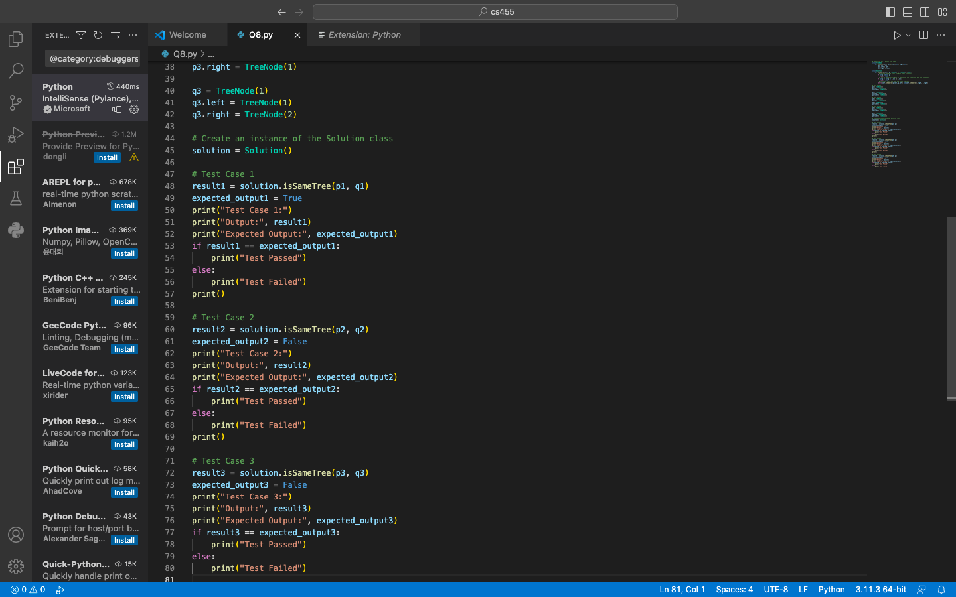

Output:

